BALLYMAHON MUNICIPAL DISTRICT

Corporate Affairs,
Please Note Venue - Aras an Chontae,
Aras an Chontae. LONGFOIRT.

6th March 2018.

To: Each Member of Ballymahon Municipal District.

Dear Member,

You are requested to attend Rescheduled Meetings of Ballymahon Municipal District to be held in The Council Chamber, Aras an Chontae, on Monday 12th March at 4.00 p.m. as follows –
Agenda.

1. To consider and approve Schedule of Ballymahon Municipal District Works - Report enclosed.

Yours sincerely,
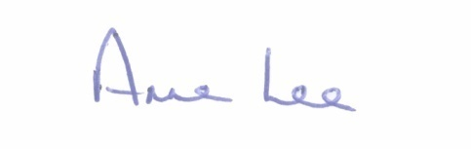

_______________
Anne Lee,
Meetings Administrator.

